JOINING SU FOOTBALL ONLINE COMMUNITY

Go to www.salisbury.edu



- Click ALUMNI in the lower left hand column. (http://alumni.salisbury.edu/)

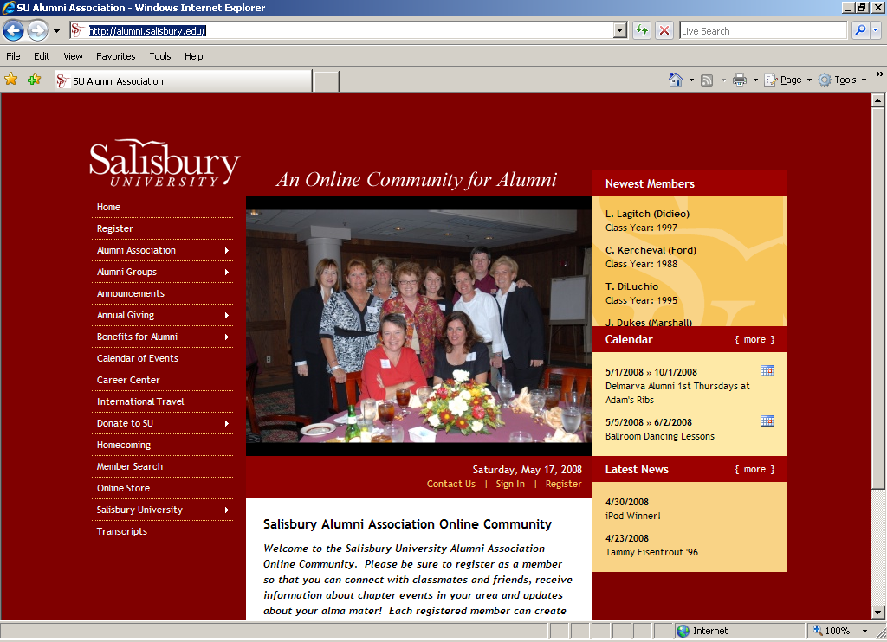

- Click REGISTER in the left hand column, second down.

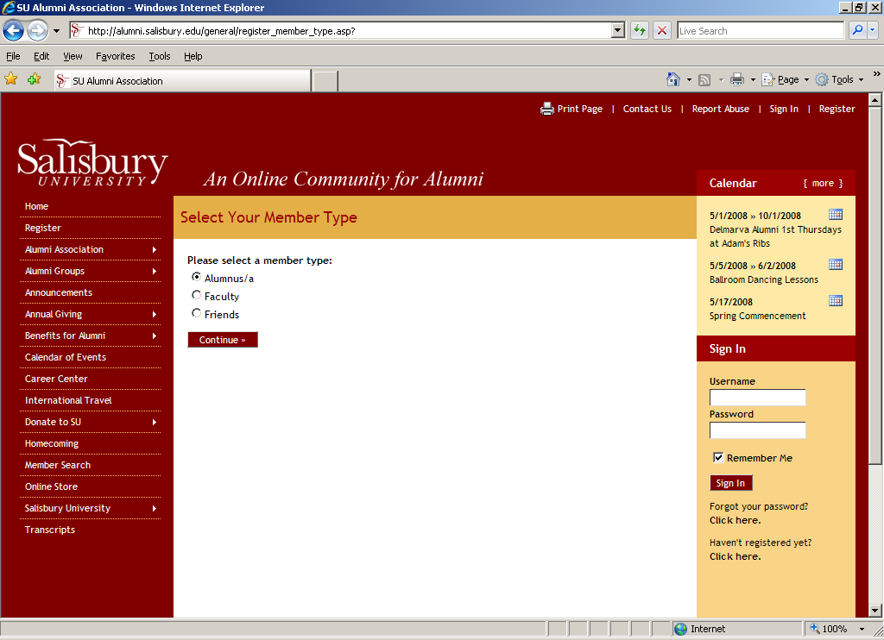

- Follow the directions from this point forward to register. (http://alumni.salisbury.edu/general/register_member_type.asp?)

…………………………………………………………………………………………

NOW YOU ARE REGISSTERED WITH THE UNIVERSITY

YOU MUST GO JOIN THE FOOTBALL COMMUNITY

4.) After you are registered. Go to http://www.salisbury.edu/

- Click ALUMNI in the lower left hand column. (http://alumni.salisbury.edu/)

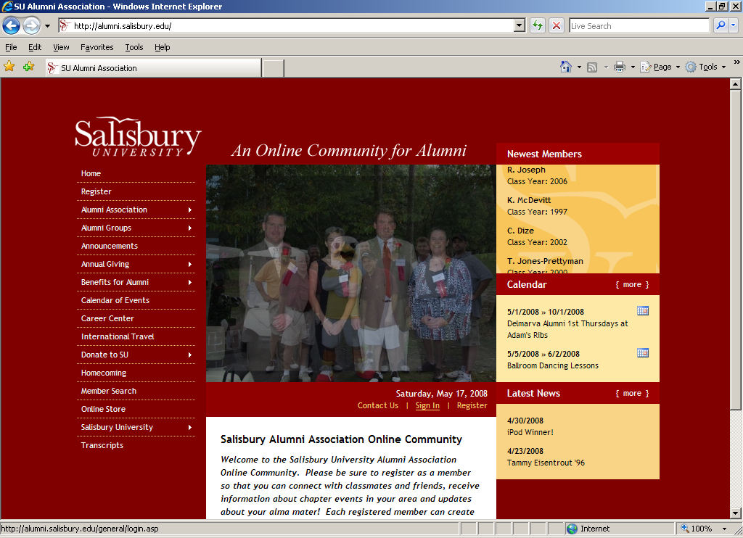

- Click SIGN IN just below the picture. (http://alumni.salisbury.edu/general/login.asp)

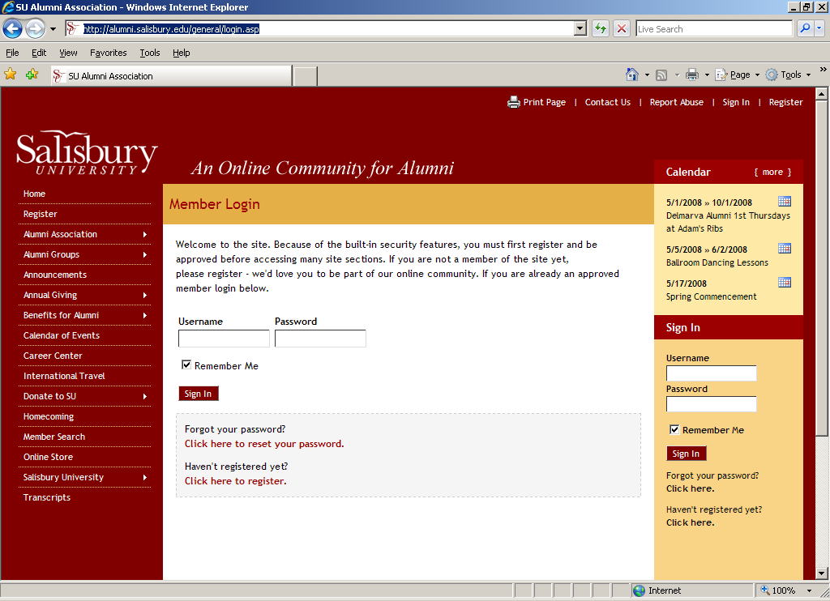

- Type in your user name and password. Click sign in

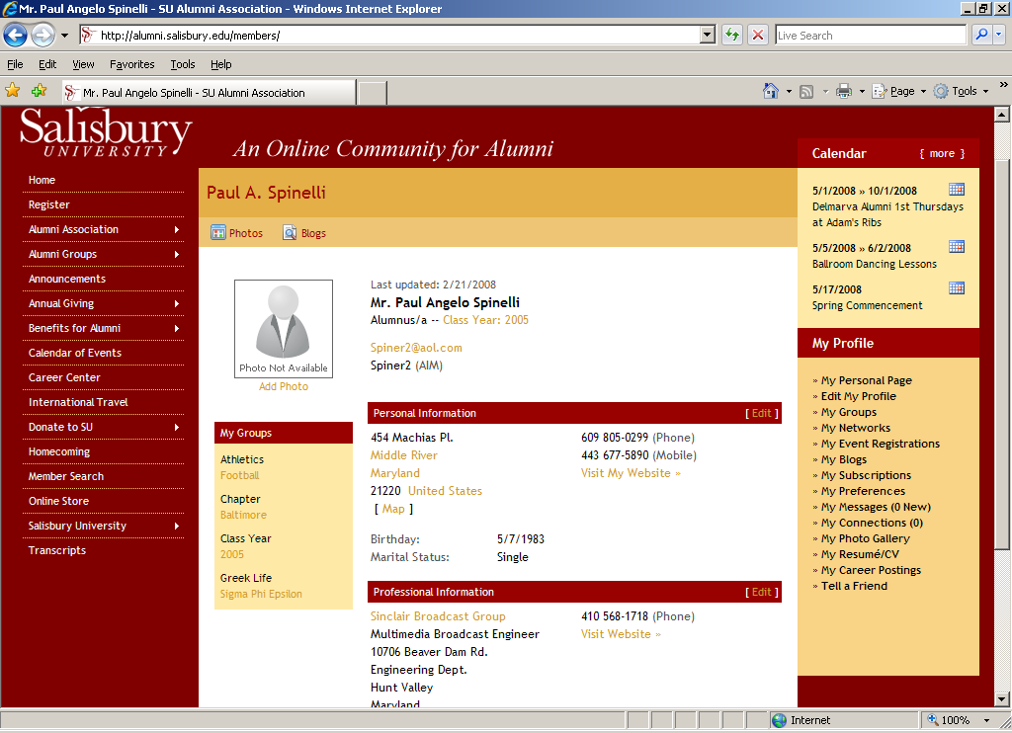

- Click ALUMNI GROUPS in the left hand column, fourth down. DO NOT click on the pop-up menu it gives you. JUST click on ALUMNI GROUPS.

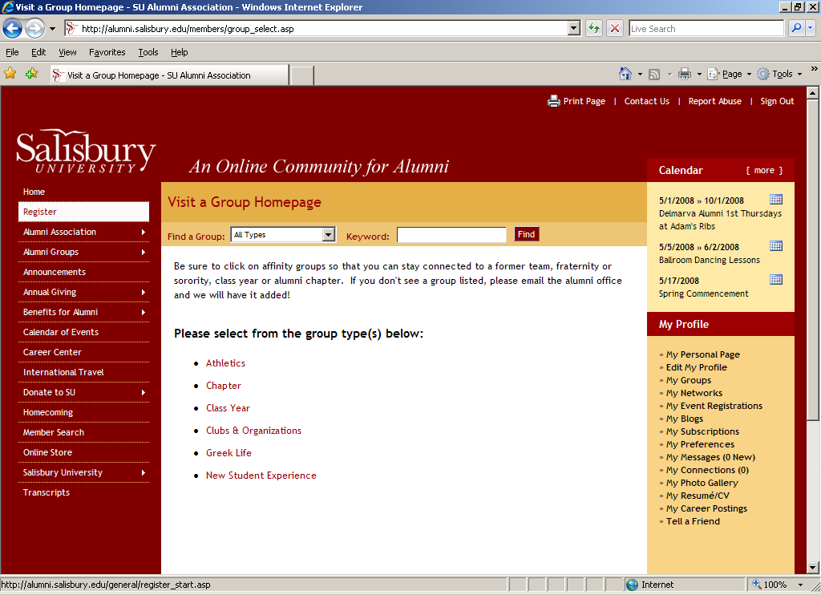

- Click Athletics.

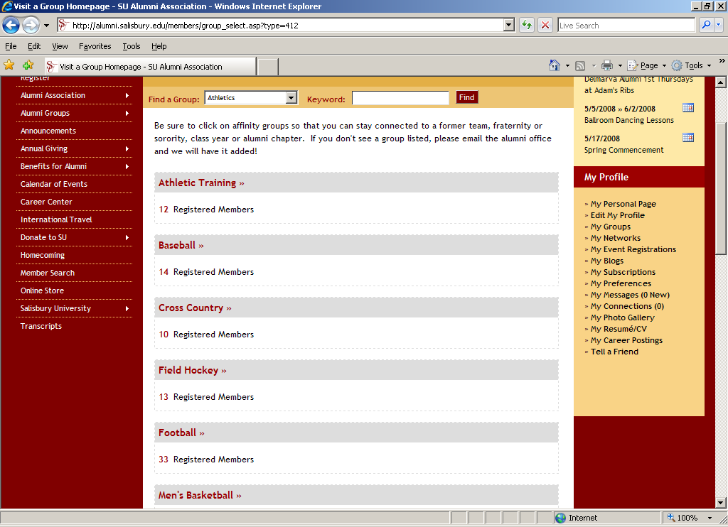

- Click Football.

- Click join group at the top of the next page.

WELCOME TO THE FOOTBALL FAMILY

